Person detection and event recognition from videos in SimMan 3G simulations – Simulated conscience

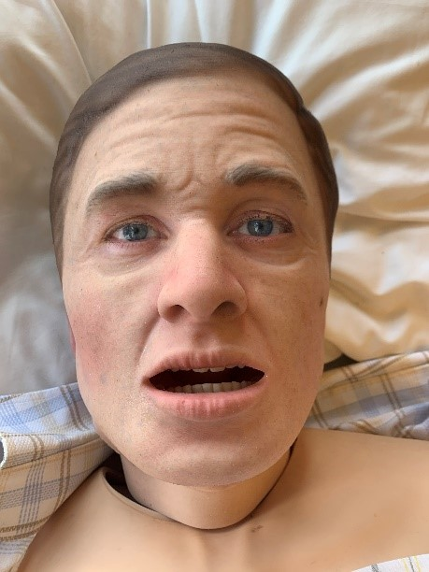

SimMan 3G is a high-fidelity patient simulator used to train teams in treating medical emergencies and trauma. The training done on this product help save the lives of trauma victims, COVID-19 patients, and many others every day. The installed base of SimMan is over 10 000 simulators. The simulator already contains microphones, speakers, an on-board computer and network connection. The control system is moving to the cloud. To improve the quality and realism of the training we aim at making the simulators more realistic both in appearance and responses. A key element in assessing a patient’s consciousness is the eye movement. An alert and conscious patient will naturally follow people and their movements in the environment. In addition. we want the simulator to respond realistically to clinical procedures involving eye movement, e.g. “follow my finger with your eyes”.

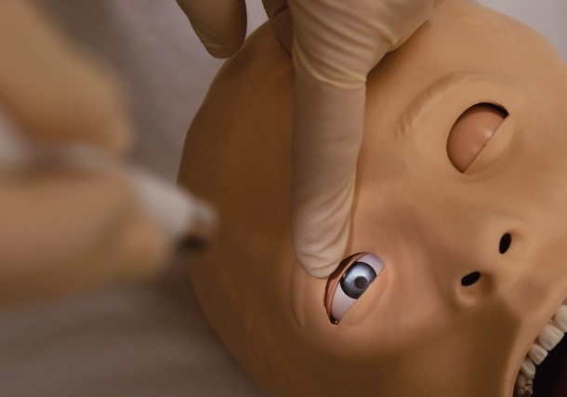Off-the-shelf low-complexity object detection networks can perform real-time object detection on images from a video stream. An example of such a network is SSD MobileNet [1] which can run on smartphones and TensorFlow Lite [2, 3]. SSD MobileNet is a Convolutional Neural Network (CNN) pre-trained on a large image dataset which can be further adapted and trained to recognize specific object classes.

The Bachelor project will include:

* 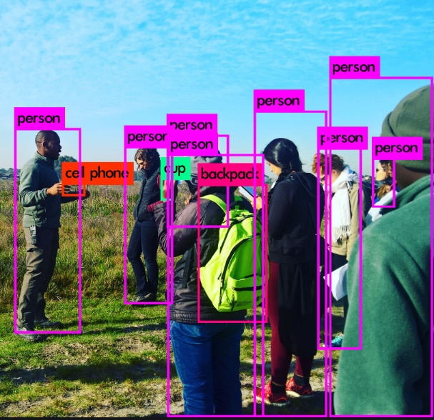A SimMan conscience simulator which can recognize and track people and a pen/finger in a «follow my finger” eye-test.
* Train an object detector to detect objects like *people* and a close-up *finger/pen*.
  + Utilize low complexity existing object detector, such as SSD MobileNet and further train the detector for the classes *person* and *finger/pen*.
  + Use MATLAB or Python/TensorFlow.
* Develop an eye-focus system which convert object detection outputs, i.e image pixel coordinates, to where the SimMan eyes should focus.
  + Involves camera calibration [4] and to convert image coordinates to eye-coordinates, i.e. where should the eyes focus in order to have eye-contact with the health care provider.
* Combine the object detector and the eye-focus system and visualize how the eyes would move when people are moving, or the follow-my-finger test is performed.
  + Visualization can be performed by plotting in MATLAB or Python.

Advisor: Karl Skretting and Øyvind Meinich-Bache  
Academic responsible: Karl Skretting

Industrial partner:  
[Laerdal Medical](https://laerdal.com/no/)

Recommended prerequisites:Bildefangst/Image acquisition   
Good programming skills  
Preferably some experience with DNN

Language requirements:  
Thesis can be written in both Norwegian and English

Contact : [oyvind.meinich-bache@uis.no](mailto:oyvind.meinich-bache@uis.no)

[1] <https://github.com/EdjeElectronics/TensorFlow-Lite-Object-Detection-on-Android-and-Raspberry-Pi>  
[2] <https://www.tensorflow.org/lite/models/object_detection/overview>  
[3] <https://www.youtube.com/watch?v=caldx99aAeA>  
[4] https://se.mathworks.com/help/vision/ug/single-camera-calibrator-app.html